Assignment Submission in LMS Course

The assignment activity provides a space into which students can submit work for teachers to grade and give feedback on.

Student View:
      - Login to LMS and open your course.
      - Look for the assignment link in respective section of the course


      - Click on the assignment link and after completing your assignment, click on “Add submission” button.

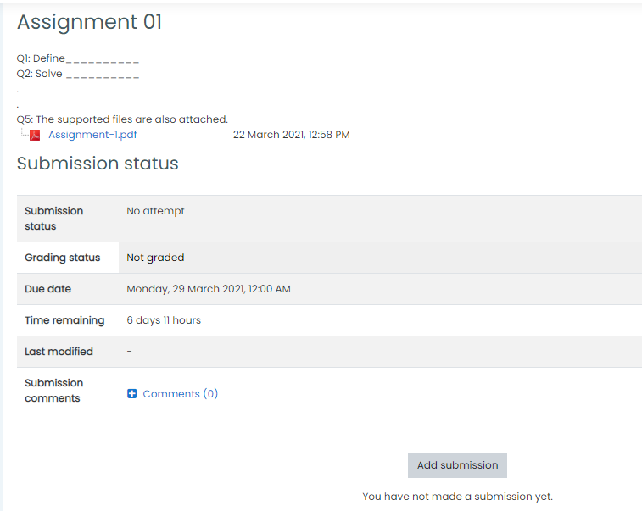

      - Depending on the assignment settings, either you will find a text box into which to type your work or an upload area to submit your file.

      - You need to explicitly accept the “submission statement” before uploading your submissions.

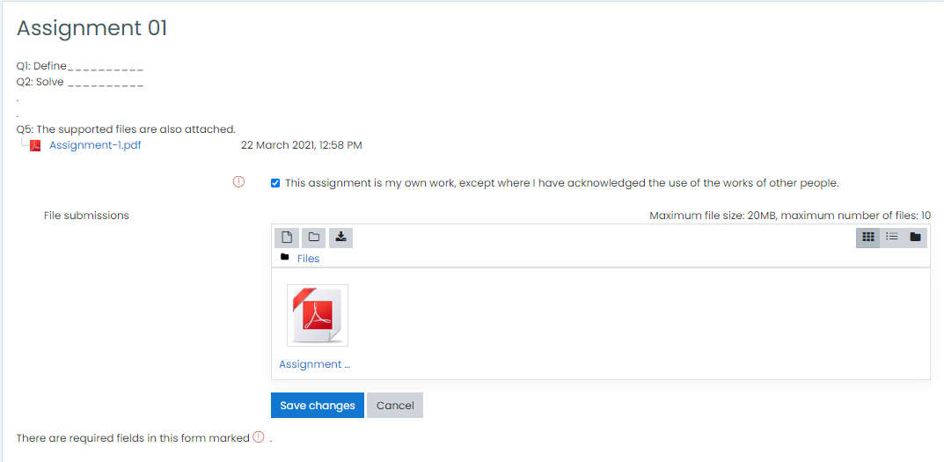

      - You may be able to return to your work and redraft it, or you might have to click a submit button to send a final version which cannot be changed.

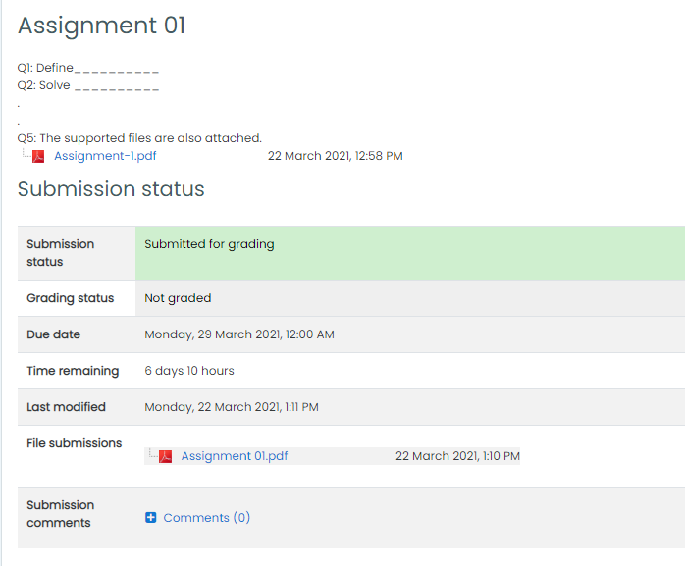
      - Once the teacher has graded the assignment, you can view the attained marks and teacher’s feedback after clicking on the assigning link.





